How to use key vault to create linked service

1. Select sql database
2. 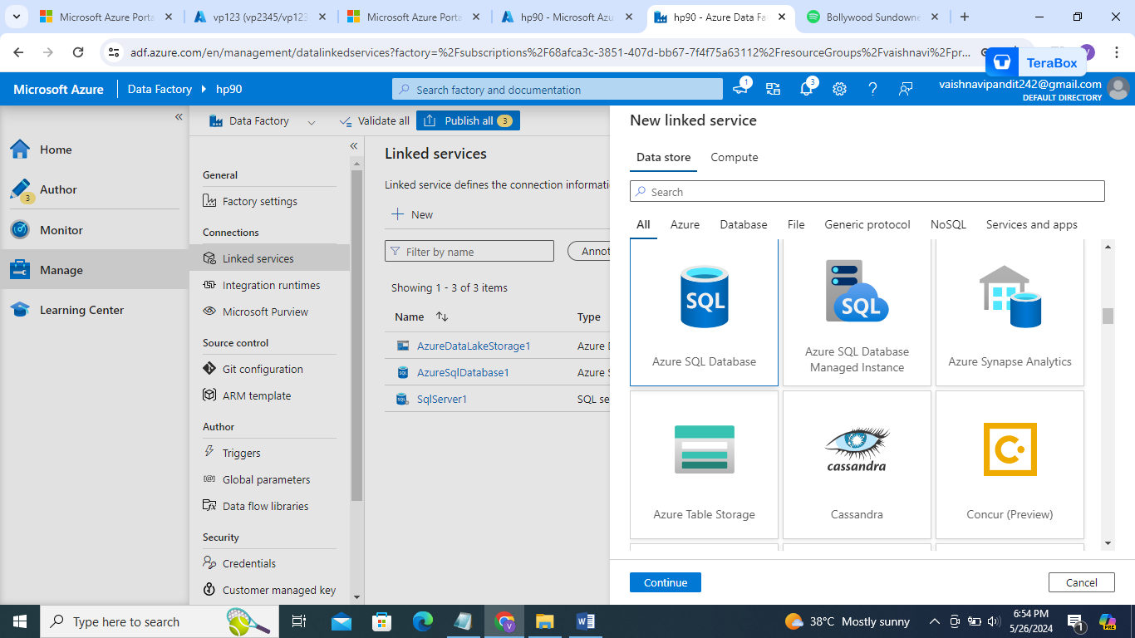
3. Add details

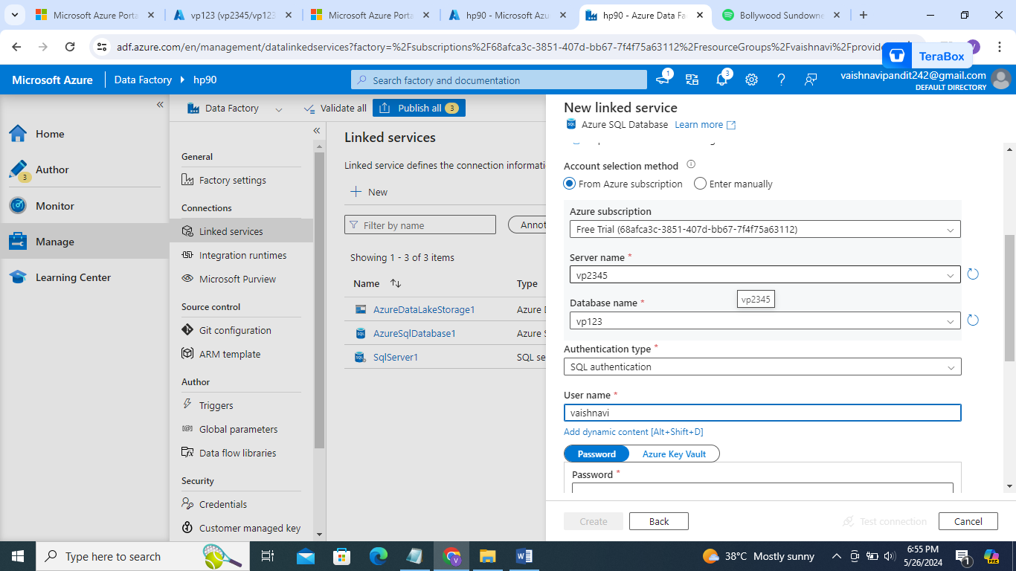

1. Select azure key valut instead of password
2. Now go to key vaults in azure

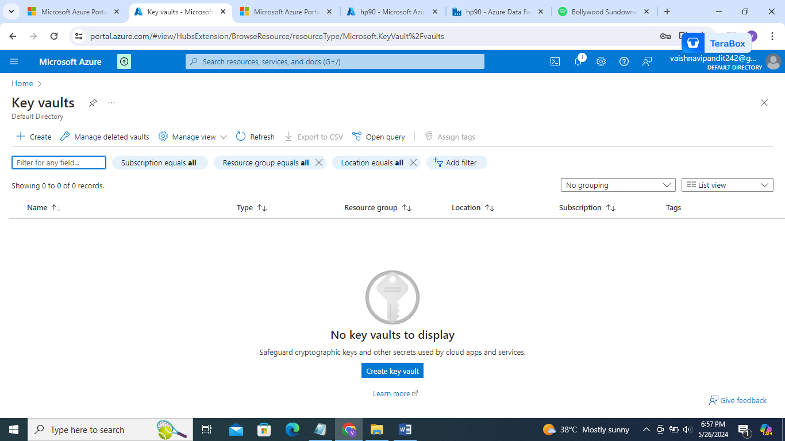

1. Now go to create

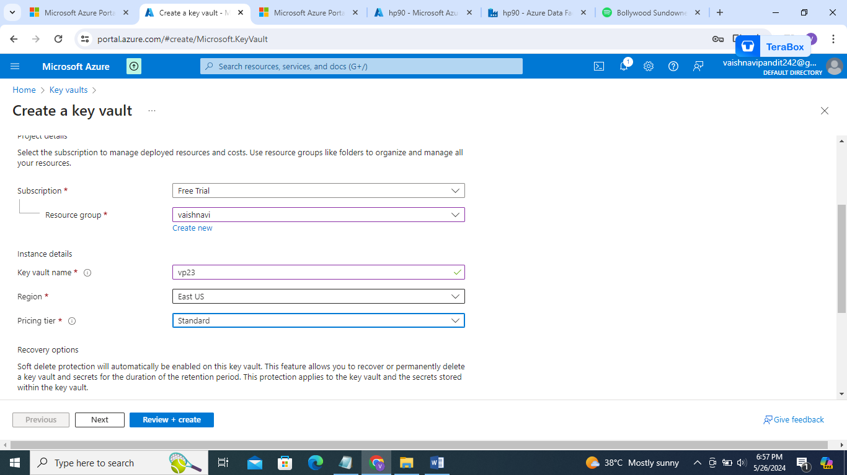

1. Go to access configuration

Select vault access policy

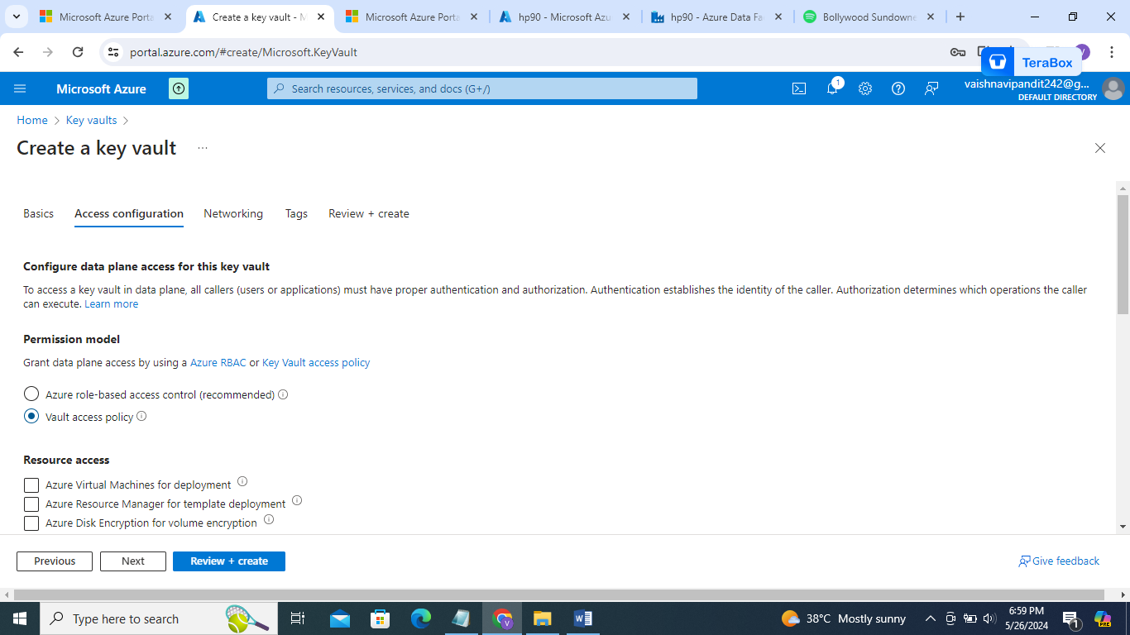

And create

1. Now go to key vault->objects->secrets

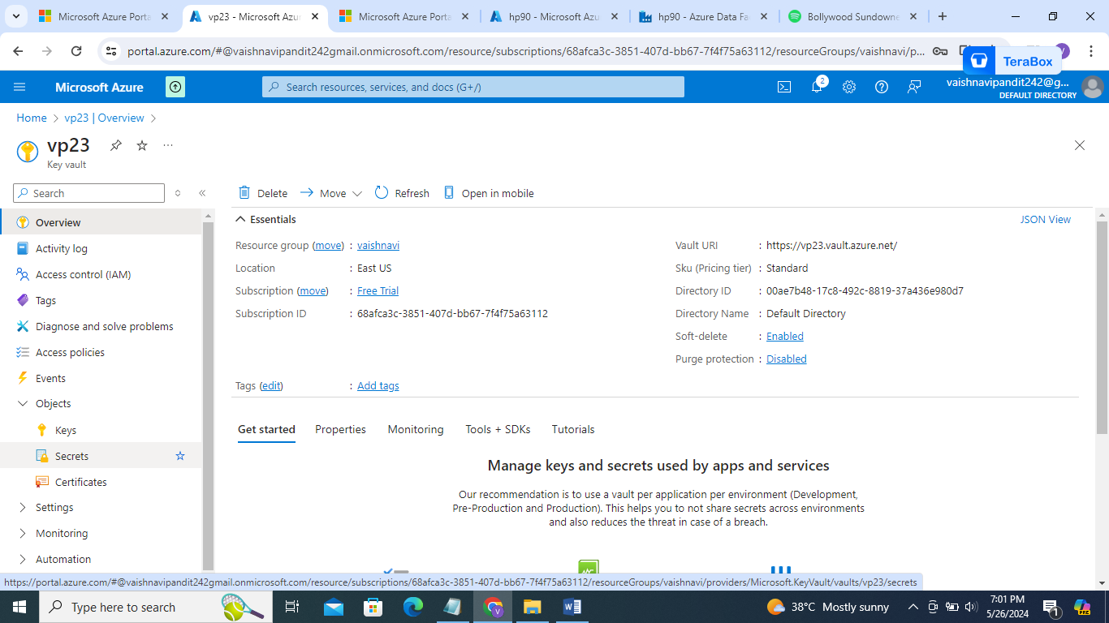

1. Create add name

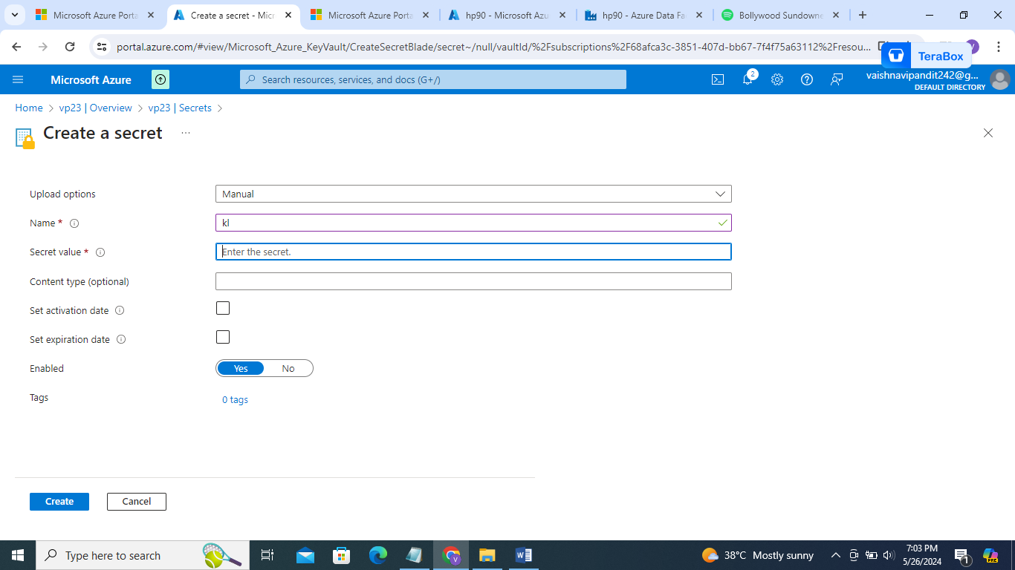

1. For secret value add password
2. Create
3. Now go to access policy

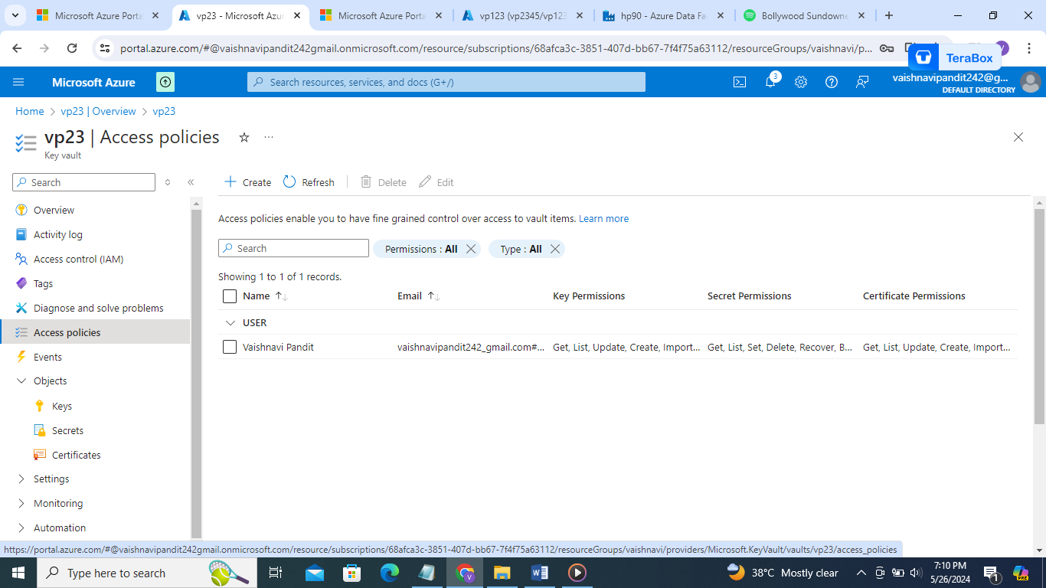

1. Create
2. Select permissions all

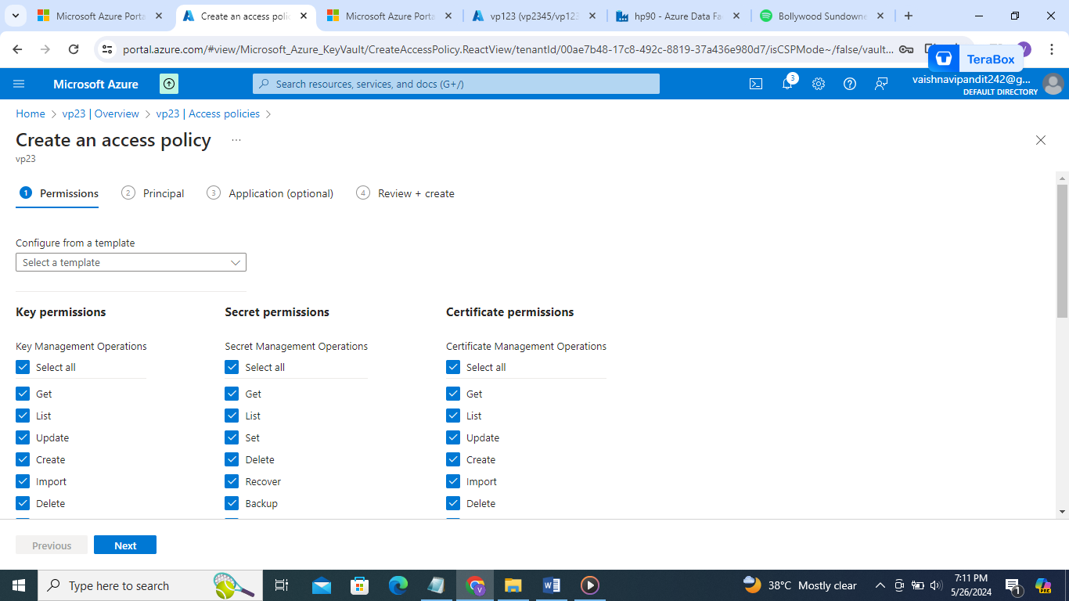

1. Go to principal

Search datafactory name and select that

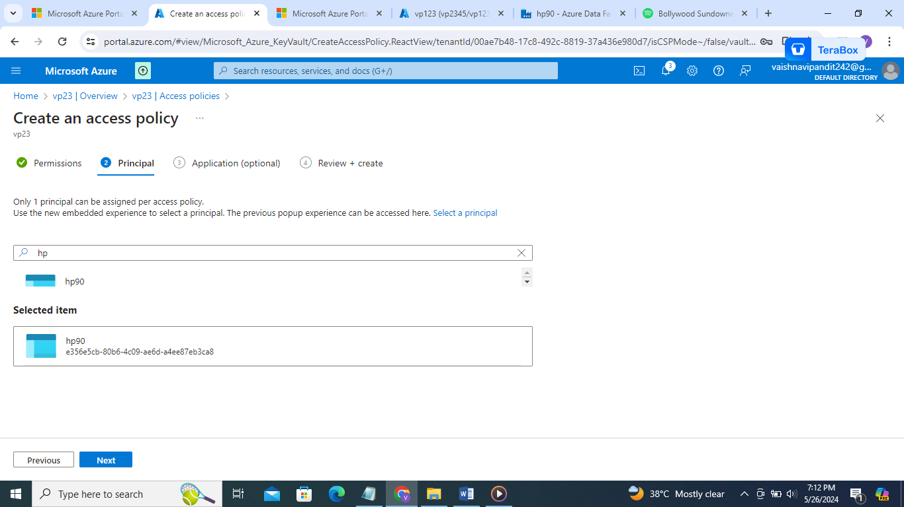

1. Create
2. Now go to azure data factory
3. Select linked service create
4. 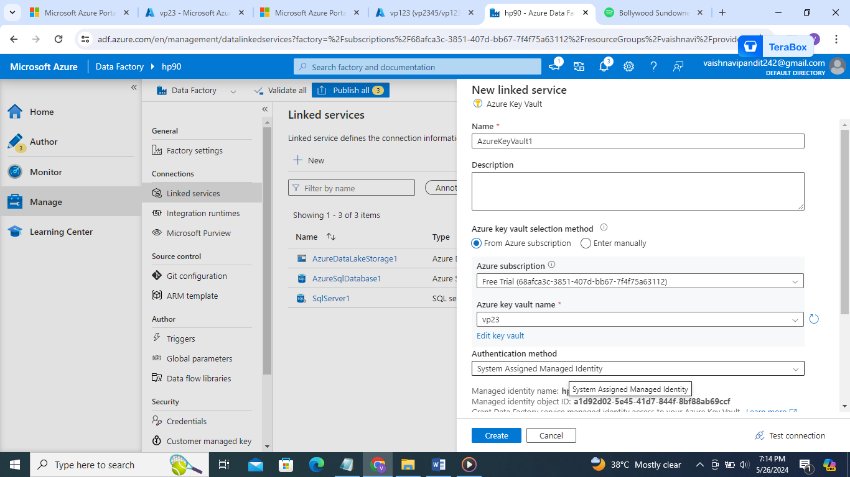
5. 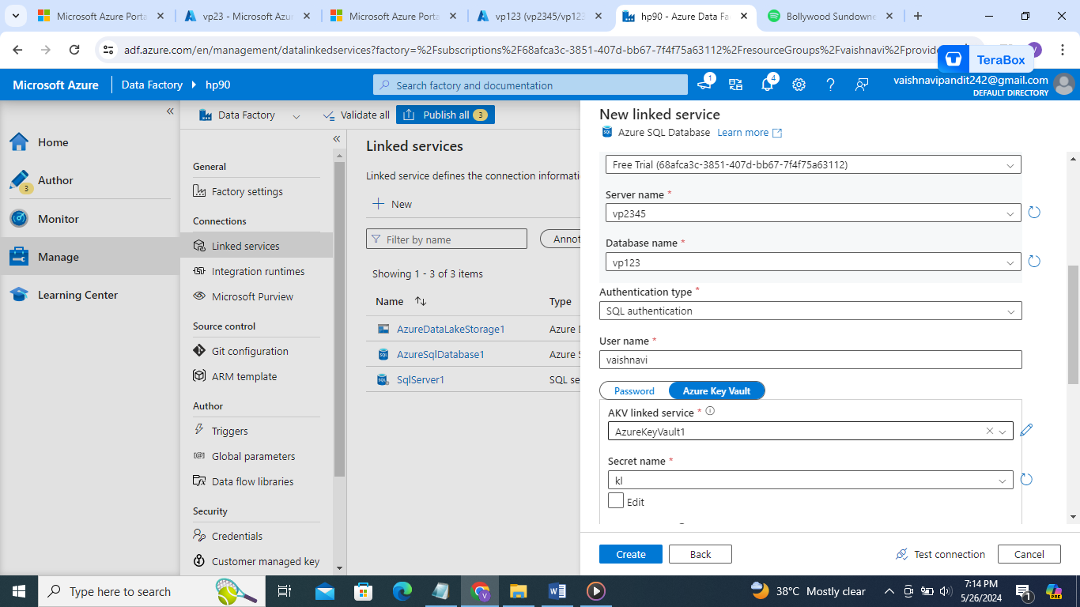
6. Create